**Original Paper**

Pradeep K. Ray1,2, Pan Chongdan1, and Mingzhong Wang3

1. University of Michigan Joint Institute (UM), Shanghai Jiao Tong University (SJTU), China, Pradeep.ray@sjtu.edu.cn
2. World Health Organization Collaborating Centre on eHealth, University of New South Wales, Australia
3. University of Sunshine Coast, Australia

# Telepresence Robots for Healthcare Management: COVID-19 Experience

**Background:** Researchers have been investigating the use of robots in the world for elderly in various types of applications, such as communication with relatives and friends at a distance, transportation of medical supplies and equipment across healthcare/aged care facilities, surgical procedures etc. In China, ground zero of the COVID-19 outbreak, robots are being used in hospitals to deliver food and medication and take patients' temperatures. Drones are deployed to transport supplies, spray disinfectants and do thermal imaging. This paper will focus on telepresence robots that have become critically important to perform remote healthcare operations, complying with social distancing measures. UNSW and University of Sunshine Coast have been partners in the European Union VictoryaHome (VH) project (2014-2016) that involved Australia and EU countries Norway, Sweden, Netherlands and Portugal. The project was aimed at better emotional health of the elderly and the project identified some major problems, such as the high cost of robot and its high complexity, making their adoption difficult. This led to the project “Robots for Elderly” as part of the new “Robots for Elderly” project (involving Australia, China, Bangladesh and EU) in mHealth for Belt and Road (mHBR) Initiative led by the UM-SJTU Joint Institute in China from 2018.

**Objective:** The aim of this study is to design, implement and test a low-cost telepresence robot for healthcare. The focus has been on implementing a low-cost telepresence robot for healthcare management for the elderly during pandemics like COVID-19.

**Methods:** This project uses an innovative, multi-disciplinary collaboration across disciplines (software, electronics engineering, mechatronics and public health)involving young university talents from these fields.

**Results:** According to preliminary customer feedback, the main functions have already been realized by our robot. The cost is approx. $500, about 20 times less expensive than the Giraff robot used in the VH project.

**Conclusions:** Many groups all over the world have been trying to develop low-cost robots for various applications. We addressed the needs for the healthcare of elderly, most affected by the Coronavirus and came up with a simple low-cost design of telepresence robot that can be deployed widely in hospitals and aged care establishments. The system is currently in a prototype level and will require an entrepreneur to commercialize it in large scale.

**Keywords:** telepresence robot; elderly people; telehealth; hospitals, aged care establishments.

## Introduction

Between year 2000 and 2050, the population aged above 65 years will double from current 8% to 16% in the world [1]. In Australia, the number of senior citizens aged over 65 years is projected to nearly double its population from 13.5% of a population in 2010 to 22.7% by 2050 [2]. It is estimated that China will have 250 million old people from 2020, yet currently available nursing centres have limited capacity, thus resulting in a scarce of caregiving resources. Therefore, there is a growing demand for wellbeing monitoring technologies, including falls detection systems, remote health monitoring, smart home technology and video surveillance which would provide them with a feeling of security and independence [3].

Telepresence Robot is a smart self-driven robot providing entertainment and Pharmaceutical features, which can be controlled by caregivers remotely. Telepresence robots are robots that provide two-way communication between two persons, which may assist in aiding the maintenance of social networks in older adults. Instead of being operated by the elderly, the robot can be controlled by caregivers’ cell phones or computers since the elderly often hesitate to handle smart electronic devices. When caregivers are away from the elderly, they can still control the pad on the robot to provide some visual or audio entertainment. Additionally, medicine can be delivered to the elderly through the robot. Thus, for the technical part, one can combine robot technology with tablets so that it can provide medication dispensation and services in addition to video communication. These robots can also act as avatars for medical staff (e.g., doctors and allied health professionals) during the outbreak of a contagious diseases, such as SARS, COVID-19 etc to save the infection to physicians and care givers.

The total estimated market size for elderly healthcare will reach about $43 billion, where nursing homes account for 40%, which is $17 billion. One can target the market of nursing homes because caregivers can control the robot.

This paper is organized as follows. The Section 2 provides a summary of the most popular telepresence robots for the elderly in the market today. This is followed by a discussion in Section 3 of telepresence robot applications during COVID-19, mostly in China. The Section 4 discusses the development of this low-cost telepresence robot by a multi-disciplinary team. The Section 5 discusses the design using QFD matrices and the prototype. Section 6 discusses the laboratory testing of the robot and its basic functions. Section 7 discusses the contextual evaluation of the prototype by people from the largest Aged Care Establishment in China followed by the conclusion in Section 8.

## The Existing Telepresence Robots for the Elderly

Robotic technologies used for healthcare can be divided into nine categories; companion, telepresence, manipulator service, rehabilitation, health-monitoring, reminder, domestic, entertainment and fall detection/prevention robots. Most telepresence robots available in market do not focus on the elderly, for instance: Giraff, Double, etc. During the design and development of these 'off-the-shelf' products, there was less consideration given to the needs and expectations of older people [4]. Some research findings have demonstrated the importance of addressing human factors in designing ICT products to attain the positive impact on the wellbeing of the elderly [5-6]. The following subsections will discuss the existing telepresence robots from the perspective of the elderly.

### Giraffrobots

The Giraff robot was originally created by Giraff Technologies AB, a small to medium enterprise (SME) based in Sweden, and later further developed within the scope of the VictoryaHome project [9]. The Giraff robot is a large machine, which includes a full-size desktop computer tower plus batteries. It has the ability to raise and lower the interaction screen, change the screen angle (like nodding the head of the Giraff), zoom the camera on a specific area, switch to night vision for dark rooms, and finely control the speed and manoeuvrability of the machine.

Evaluations of the device were in the form of a controlled research trial with the results meant to inform further development of the device in order to provide a solution that would, as closely as possible fit the needs of older people living in their own homes. The trial was extensive with 20 private homes of elderly users, across Europe and two more in Australia. As the trial was designed to determine the usefulness of the Giraff robot, a series of questions were asked both from the primary user (the elderly) and the secondary users (the caregivers) perspective.

The Giraff can be remotely activated by a 'secondary user' (care workers and loved ones who want to contact the primary user using the telepresence robot) to request a visit to the 'primary user' (the older person). The primary user can see an image of the caller on the Giraff screen and can either accept or reject the incoming call. Some secondary users can also be given permissions that allow them to make 'emergency' calls, where they can activate the Giraff and start a visit without any intervention by the primary user, in order to check the well- being of the primary user as may be the case with a suspected fall.

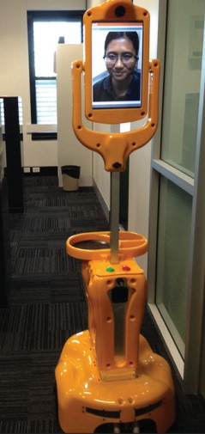

Figure 1: The Giraff robot

The Giraff robot has been evaluated in various sites in Europe (7) and at two sites in Australia. However, It is too expensive (approx US$10,000) for home use. Besides, it has problems such as firewall issues, video freezing, and driving lag etc, but it can be a reference based on which one can design and build a low-cost telepresence robot.

### Double

The Double robot [10] was originally created by Double Robotics which was founded in 2012 in California. Both Double and Double2 consist of three major components: a charging dock, a self-balancing base with two wheels and motors, and an iPad serving as the "brain power" as well as the cameras and speakers. Double and Double2 can be driven by an iPhone/iPad with its iOS app or by a PC or MAC with Google Chrome or Firefox browsers. They can be remotely controlled to park and to raise/lower its head to suit sitting and standing scenarios in addition to forward/backward/left/right moves.

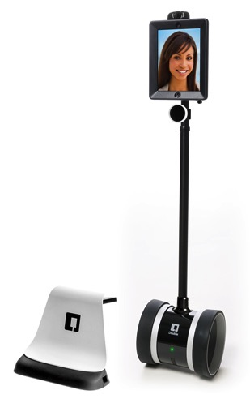

Figure 2: The Double 2 robot

Similar to the evaluations of the Giraff robot, Double 2 underwent a controlled research trialat Sunshine Coast, Australia to explore the match and gap between the existing functionality and the needs of older people living in their own homes. However, the participants were reluctant to adopt an iPad only solution. Moreover, the reliance on the attached iPad for camera/video/audio and communication limited the capabilities of Double 2. It also suffered the problem of driving lag due to the Bluetooth-based connection between the iPad and the base. The trial suggested that the telepresence robots for the elderly and healthcare should be flexible and extensible.

Coincidently, Double3 was released in 2019 to have its own “head” by replacing the iPad with an open and extensible solution using an Nvidia Jetson TX2 embedded AI compute module, Ubuntu Linux 18.04, and off-the-shelf sensors. As a result, Double 3 claims to support self-driving and mixed reality.

### Newme

Newme[11] is an avatar robot unveiled in 2019 by OhmniLabsfrom California. Its mission is to integrate various disruptive technologies, such as robotics, AR/VR, and AI, to achieve the telepresence of people.

Newme caught the public interests when it was deployed in the April 2020 graduation ceremony of Business Breakthrough (BBT) University, Tokyo (Fig 3). Due to COVID-19, graduate students could not attend a traditional graduation ceremony in person, but got represented by a Newme telepresence robot.

Newme robots have also helped people with debilitating paralysis to return to the workplace as robot waiters in Japanese cafes, proving that the potential for these technologies really are limitless.

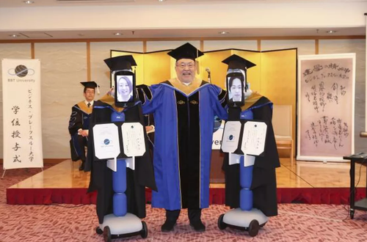

Figure 3: BBT University President Kenichi Omae poses with the students who are using robots to attend graduation. <https://www.9news.com.au/world/japanese-robots-replace-students-university-graduation-due-to-coronavirus-isolation/d49a56ce-bfa1-4545-b6c5-0dd85344e34b>, April 7, 2020

It is not clear if Newmehas a good fit into the healthcare of the elder people. However, the experience of OhmniLabs suggests that the cost is a key factor for the success of telepresence robots. OhmniLabs claims to produce robots at 5-10 times lower cost than traditional methods [11].

Although there are dozens of different models of telepresence robots available on the market, only a few of them, such as Giraff and Double 2,were trialled with the elder community. The lessons learnt, including the requirements of flexibility, extensibility, and economy, guide us to design FLEXTRA, a Flexible Telepresence Robot Assembly.

## Telepresence Robots used during Coronavirus Outbreak

Since the Coronavirus is highly contagious, telehealth and mHealth have become very important to protect various types of service providers, particularly health professionals (e.g., doctors and nurses) from infection by patients and clients who may not know that they have an infection in view of the 2 week incubation period. While hospitals are focusing on patients with confirmed Coronavirus infection and its effects, the society has to deal with people who do not have confirmed coronavirus infection, but they may be suspected (e.g., people coming from a cruise).

There have been many news reports of the use of telepresence robots during the coronavirus outbreak and the main types are:

### Remote temperature monitoring

Remote temperature monitoring at public places like airports and also tests for coronavirus:asystem developed by Chinese tech giant Baidu – best known for its search engine – is being used to screen train passengers in Beijing[[1]](#footnote-1). It harnesses infrared and face detection technologies to detect fevers in anyone passing through the station. Register a temperature of 37.3 degrees Celsius or higher and the systems flags prompting a secondary check.

Baidu has said the system can check more than 200 people per minute, with a margin of error within 0.05 degrees Celsius [12].

### Remote consultation between health professionals and patients

In a bid to minimize person-to-person contact, artificial intelligence-powered devices equipped with thermometers and cameras are taking patients’ vitals and helping doctors diagnose people with the illness from a safe distance [14].

### Contactless delivery of food and medicines

In China’s south eastern province of Guangdong, an area identified by the World Health Organisation as a coronavirus hotspot, doctors at the city’s Provincial People’s Hospital have been using robots to deliver medicine and food to patients. The two-wheeled droids, shaped like a small refrigerator, can navigate the halls of the hospital autonomously, opening and closing doors where necessary to reach infected people in quarantined areas of the hospital [13].

### Disinfect rooms with ultraviolet light and remove germs[[2]](#footnote-2)

The Odense, Denmark-based company [is scaling up](https://www.therobotreport.com/coronavirus-fight-china-gets-boost-uvd-disinfection-robots/) to meet global demand.Shanghai-based TMiRob [has deployed](http://www.xinhuanet.com/english/2020-02/07/c_138763788.htm) 30 disinfection robots across hospitals in Wuhan, the epicentre of the COVID-19 outbreak. Wilmington, Mass.-based [Xenon Corp.](https://xenoncorp.com/) provides UV-C lamps to [Xenex Disinfection Systems](http://www.xenex.com/" \t "_blank). San Antonio, Texas-based Xenex’s robots are designed to reduce healthcare-associated infections in hospitals, and it claimed that its LightStrike UV robot [is already in use](https://www.jpost.com/HEALTH-SCIENCE/Robots-take-on-coronavirus-618551) in 500 facilities in the U.S [15]. Meet Sadie. She's one of 32 germ-zapping robots Honor Health hospitals now have to clean patient rooms and the ICU with UV light. It gets rid of the residual viruses and bacteria and spores [16].

### Replace hospital reception staff with robots to answer questions by patients and family members

One such machine is the Temi robot. Developed by an Israeli company, Temi is three feet tall and features a touchscreen, Amazon’s Alexa technology, a built-in sound system, a tray for charging phones and an autonomous navigation system that allows it to move around on its own while avoiding obstacles [14].

Having seen these different types of applications of a telepresence robot for both aged care and for COVID-19, we now discuss the development of a low-cost telepresence robot suitable for both aged care and for COVID-19.These five scenarios will be used to evaluate (in Section 7) a telepresence robot discussed in the next two sections.

## FLEXTRA:ALow-Cost Telepresence Robot

This Section presents the design of a FLEXible Telepresence Robot Assembly (FLEXTRA) that may serve as a basis for many applications of telepresence robots for the elderly , especially in the case of pandemics like COVID-19 applications discussed in the previous Section.

As stated in the background, this project started with the experience of the team in the EU Victoryahome[[3]](#footnote-3) project [9]. Hence the initial specification was taken from the robot used in the Victory Home project for which trials were carried out in Australia, Norway, Netherlands, Portugal and Sweden.

This project encouraged innovative students of University of Michigan – Shanghai Jiao Tong University Joint Institute (UM-SJTU JI), led by Pan Chongdan who led the SJTU team to the World championship in robot design in 2019. Students were encouraged to form a multi-disciplinary team consisting of JI final year students in Mechanical Engineering, Electrical and Computer Engineering and largest Aged Care company (Haiyang group) in China. The main strategy has been to exploit recent advances in embedded computing, tablet based low-cost robot display, and mechatronics dynamics for the robot. The design uses Quality Function Deployment (QFD) matrices from the Total Quality Management (TQM) domain.

### 4.1 Design Principles

Addressing the issues and experiences with existing telepresence robots, FLEXTRA tries to achieve the following expectations.

#### 1.Functionality

The functionality should be similar to Giraff robots, including video communication, remote control, 6-way movement, medication dispensation, and fall detection.

Moreover, special considerations should be given to the functionality for the elderly as they usually have different needs and characteristics. For example, the robot should be able to store the pills for a long time when caregivers are away, and the pills should not go bad. It is also common that they need to take different pills at different time. Therefore, the medicine dispenser should be capable of dispensing various combinations of pills each time.

#### 2. Economy

The cost should be under $1000 for the required functionality. As the products in the market are above $3000, it implies that FLEXTRA should focus on the Minimally Viable Product (MVP), and the main challenge is to redesign, simplify the robot, and implement the essential functions at a lower cost.

#### 3.Stabilityand Usability

As the telepresence robots are controlled remotely via Internet, it becomes important that the quality of control and communication should not be affected by lags or firewall. The users on both ends should be able to see and hear clearly through the robot, and the remote control should get instant response.

#### 4. Safety and Power

As the robots become part of the living environment of the elderly, safety becomes a critical requirement. The robot structure should be stable to avoid tumbling, and the nominal voltage should be low, e.g. less than 30V.

In addition, the robots should have a high-capacity battery so that they do not need frequent charging.

#### 5. Flexibility and Extensibility

Users have varied needs for the robots. Even for the very basic application of video chatting, the elderly may be more familiar with and prefer Skype, Zoom, or others. Therefore, it is important that the robots are extensible and customisable to be tailored with various features and functionality.

### 4.2 Requirements and Specifications

Based on the principles and expectations shown in the previous section, the refined requirements of FLEXTRA can be divided into the software and hardware components.

#### Hardware

1. The screen, along with its control buttons, should be large enough.
2. The speaker should be loud enough for the elderly.
3. The height of the screen should be suitable for users who might sit in a chair to interact.
4. The medicine dispenser should be located at a suitable height.
5. The medicine dispenser should have large storage.
6. The medicine dispenser should provide dry environment to store the medicine.
7. The moving speed of the chassis should not be too fast or too slow.
8. The battery duration of the robot should last sufficient time.
9. The physical entity of the robot does not contain any sharp edges.
10. The hardware is extensible that new sensors and actuators can be easily added.

#### Software

1. The control (both local and remote) of the robot should be easy.
2. Alarm function should be added to remind the elderly to take medicine.
3. The applications are flexible and customisable based on users’ preferences.

In addition to the functional requirements listed above, the total cost of the robot should be below $1000.

Table 1 summarises the engineering specifications and requirements for the FLEXTRA robots.

|  |  |  |
| --- | --- | --- |
| Item | Unit | Target Value |
| Speaker Loudness | dB | 80 |
| Moving Speed | m/s | 0.2-0.5 |
| Remote Control Lag | sec. | *<*0*.*2 |
| Video Lag | sec. | *<*1 |
| Battery Capacity | mAh | 20k |
| Cost | US Dollar | *<*1k |

Table 1: Specifications of FLEXTRA

## Design Processing Using QFD

The Quality Function Development matrices help design systems from relatively vague customer requirements by quantifying them through the QFD process. Its application in FLEXTRA results in a matrix as shown in Fig.5, which lists12 customer requirements and 10 engineering specifications, rates their relationships, and calculates the priority. Each strong relationship counts as 9 points, each moderate relationship counts as 3, and each weak relationship counts as 1. Multiply by the importance points of the requirements, we can calculate the weighted average of each specification. The specification with highest weight has the highest priority. As a result, the remote-control lag is the most important, and the motor power and the weight follow. The least important is the dB of the speaker.

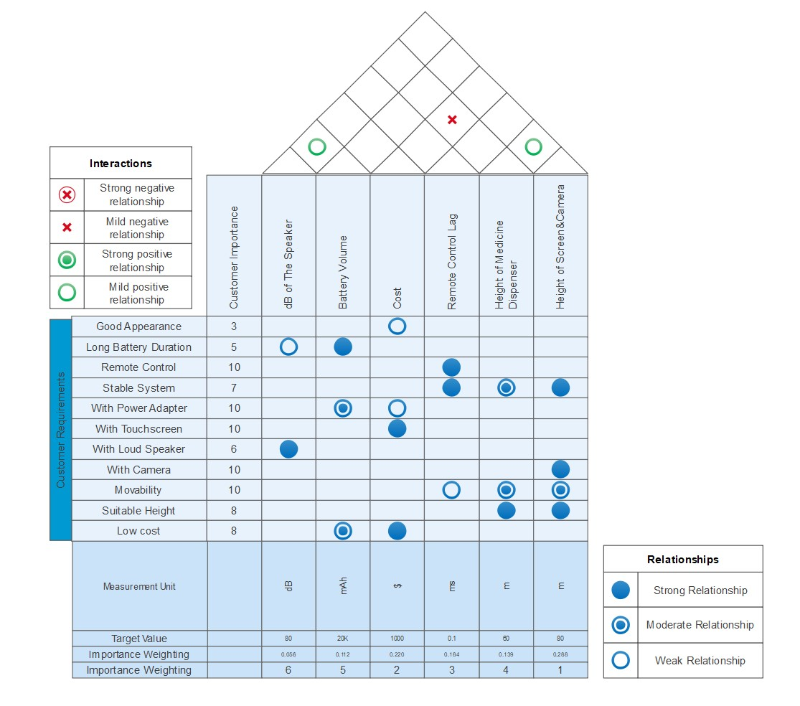

Figure 5: QFD table of our project.

Once the priorities of the design are decided, one solution needs to be selected from several design choices using Pugh’s concept selection method. This will be illustrated by the design of the Medication Dispenser.

### 5.1 Medicine Dispenser

More than 50% of the older people are living with multiple chronic illnesses [9]. Thus, routine monitoring and assessment of the individual’s adherence is crucial to improve their health outcomes. Elderly with multiple chronic conditions face the complex task of medication management that can involving multiple medications of varying doses at different times. Advances in tele-health technologies have resulted in home-based devices for medication management and health monitoring for the elderly. The function of such medication dispensers is to alert the patient when it is the date and time to take their prescribed medication[9]. When the time comes to take the medication, the pill dispenser automatically releases a pre-measured dose for consumption. Some of the features are:

* Provides audible, visible or vibration alerts.
* Dispenser must be locked once medicine is replenished.
* Long distance connectivity to track use.
* Humidity resistant and tamper proof.
* Dispense only the prescribed amount at the required times.

For the medicine dispenser of FLEXTRA, key factors in the design include the budget constraint, the end users, and the safety standards. It means that the design has to operate with few electrical components (motors, servos, etc..), to be simple enough to enable low-cost 3D printing, to be easily handled by the elderly and their caregivers, and to comply with the safety standards (correct dosages, tamper proof, and humidity proof).

Based on the way that the pills would be sorted and delivered to the users, two possible design concepts were proposed:

* **Mixed Pill Manual Sorting**: the daily medication would have to be sorted by the caregiver and the cocktail of medication would have to be put into each slot manually. The dispenser would then rotate at the desired time so that the medication that was in the next slot would fall into a tray and be consumed by the user.
* **Pill Blocks Automatic Sorting**: would have blocks in which each block would contain one type of medication, and the system would separate them automatically depending on the demand. The system would dispense into a tray the desired amount of each pill at the designated time. Each block would have its own mechanism to make sure that only a single pill would be released at a time, so that the user would have the correct dosage of medication.

#### Concept Selection Process using QFD Pugh Method

To decide a solution from two optional design concepts, the Mixed Pill Manual Sorting and the Pill Blocks Automatic Sorting, Pugh method was applied. A scoring matrix was constructed to compare different concepts against the requirements (price, user, and safety), thus ensuring the best decision. Fig.6provides the matrix for comparison between the two concepts and the selection based on the best choice.

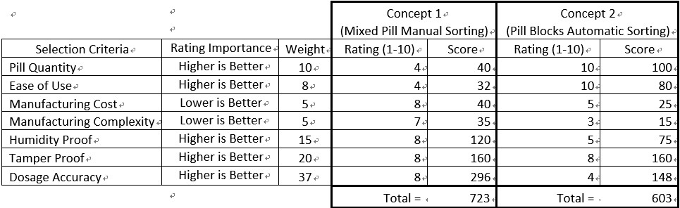

Figure 6: Concept Selection Scoreboard

We can see from the criteria and the weights that the safety aspects of our medicine dispenser outweigh the usability and cost. Therefore, the Mixed Pill Manual Sorting concept was chosen for FLEXTRA as it has a higher score in the comparison.

The chosen concept leads to the final design of the medical dispenser which consists of five main sections as shown in Fig. 7.

* The stepper motor, gears and bearing (orange and red) are responsible for the movement of the dispenser base.
* The support beam (silver) is connected to our chassis, and it supports the gearbox, bottom dispenser base and the pill tray which are all fixed to it.
* The gearbox (green) houses the moving parts so they are safely away from the users as well as keeps the dispenser suspended and rotating freely with the bearing.
* The dispenser lid and base (blue and transparent) house the pill boxes and keep them humidity proof. The lock (pink) locks the dispenser lid in place so that once the pill boxes are inside the dispenser. They are tamper proof.
* The pill tray (yellow) receives the pill boxes once they drop from the dispenser, making it easy for the user to administer the drugs.

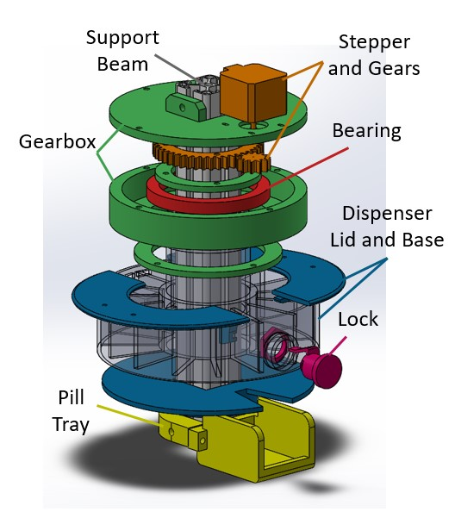

Figure 7: 3-D View of the Medicine Dispenser

All the necessary components can either be bought (bearing, stepper motor and lock) or 3D printed (gearbox, gears, dispenser and pill tray) to meet our engineering specifications and requirements.

### 5.2ChassisImplementation

The chassis is the home of wheels and motors which enable the mobility of the robots. Considering the end users of FLEXTRA, the chassis needs to

* be stable enough to support a one-meter-long aluminium rod with a bunch of components installed on it,
* have the required mobility such that it can move freely in narrow places at home,
* have enough space to host electrical components and batteries, and cover them well so that there is no risk of exposing them to hurt the elders.

We use the universal balls at the front and the back, so that the weight centre of the robot will not change during turning process. The driving wheels are directly connected to the motors. The batteries are also hosted inside the chassis to supply power to the robots. In the centre, a square hole is prepared for the aluminium rod, so that the connection between chassis and upper components are stable (Fig. 8).

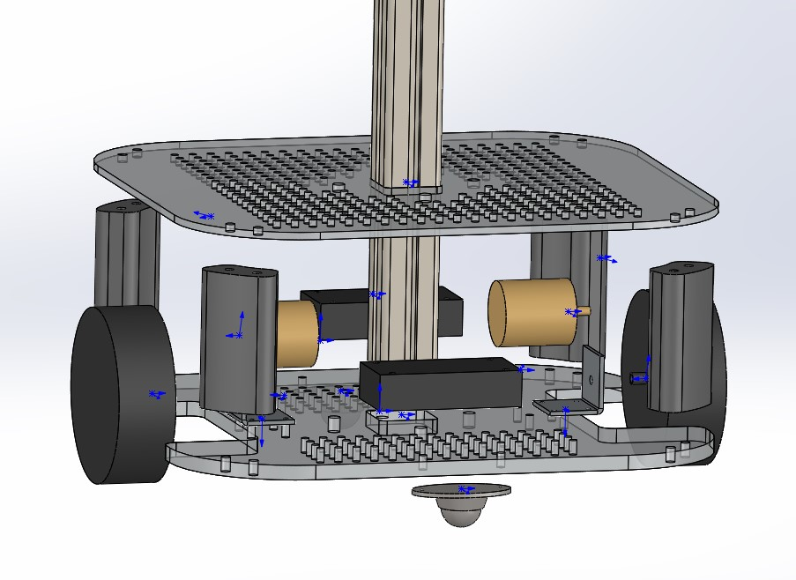

Figure 8: Exploded View for Chassis Design

### 5.3 Controller, Screen, Camera and other Actuators and Sensors

A big screen is required as the human-computer interaction interface for the elderly as they usually require extra aids in reading. With such a screen, the elderly can communicate with the caregivers visually and freely.

A camera with wide-angle lens and zooming support is also a necessary feature. As such a camera can help caregivers to capture broader scope of the surrounding environment or to inspect some spots of interests with greater details, it becomes much easier to control and move the robots.

Actuators and sensors are the add-ons to extend the functionality of the robots. There are no specific add-ons are included in the FLEXTRA, but it is important to guarantee the extensibility.

Therefore, FLEXTRA utilises Raspberry Pi, a low-cost yet powerful and versatile single-board computer, as the controller to connect all hardware components. With the support of Linux operating systems and general-purpose input-output (GPIO) connectors, Raspberry Pi has great extensibility and has won great popularity in embedded computing and robotic communities. The use of Raspberry Pi will benefit the future of FLEXTRA as innovative functionality can be transferred from the open-source community.

Fig. 9 illustrates the circuit design and the connection of different hardware components.

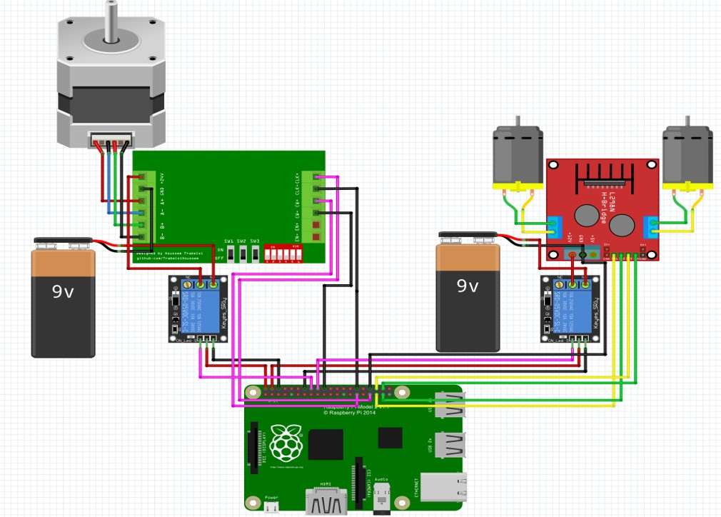

Figure 9: Circuit Design of the Control System

### 5.4Software Implementation

From the software perspective, the engineering specifications and custom requirements of our design lead to the implementation of three major components:

1. The video streaming system.
2. Device management system to remotely manage the Raspberry Pi and the pad.
3. The control system which allows remote control of the robot.

#### Video Streaming System

To support video communication with the elderly and provide visual guide for the remote control of the robot, a video streaming systemis required to exchange real-time information between users. We decided to use aWindows tablet on which the video communication system is alreadyimplemented. With this tablet, users can choose whatever video chatting tools they prefer, such as Skype, Zoom, or WeChat, to use.

#### Device Management System

As ordinary computers, users need to perform housekeeping jobs (installation, uninstallation, add/delete users, etc.) on the Raspberry Pi and the pad in the FLEXTRA. It is common that caregivers need to do these by remotely logging into the devices. We decide to use TeamViewer, a mature software for remote device control, to realize this function. The inclusion of TeamViewer aligns well with our custom requirement and engineer specifications because it supports multiple platforms and offers stable remote controls. Moreover, TeamViewer offers a private communication channel guarded by the 256-bit AES encryption scheme.

#### Control System

To remotely control the movements of robots, we developed a web-based remote control system running in the Raspberry Pi.. Fig. 10 shows its graphic user interface which is intuitive to use.

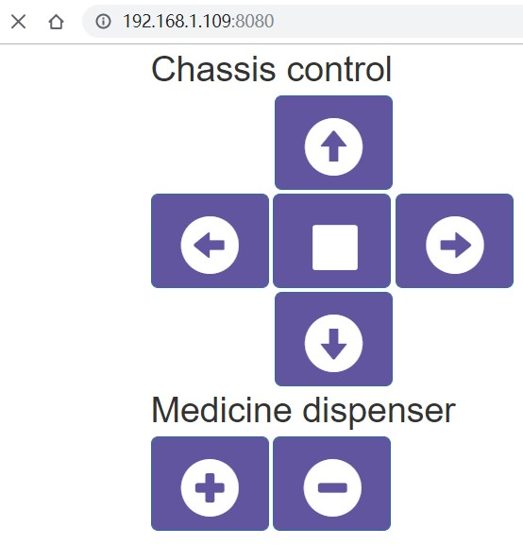

Figure 10: User Interface of the Control System

## Testing Plan

There are three major criteria to evaluate the quality of the product: the chassis movement, the medicine dispenser, and the remote video communication. This section we will present experimental set up to test their corresponding engineering specifications. For other engineering specifications such as the loudness of the speaker, the volume of the battery, the height of the screen, and the screen resolution, they can be directly measured or validated by reading the manual for each component used.

### 6.1Chassis movement

To set up this experiment, a clear field is needed with a line of length 5 meters measured. The robot is placed at one end of the line. At the other end, a chair with person sit on it should be placed in a different direction with the robot. Through remote control, the robot should be able to forward in a straight line for the 5 meters, and then turn to the person. The user that control the robot cannot see the situation in the field directly. He or she can only move the robot using the view provided by the camera on the robot.

In this experiment, we will validate the moving speed of the robot and the video streaming specification. The test result shows that the moving speed of the robot is 0.4 m/s, the lag for remote control system is 0.1s. and the user can see the situation around the robot clearly through the camera. The robot can move straight and turn easily according to user’s instruction and succeed in moving to the assigned place.

However, when the robot is going to speed up or slow down, it will wobble because its gravity centre is very high. So we decided to adjust the layout of the robot chassis after the experiment by lowering down the chassis. After the adjustment, we did the second experiment. The lower gravity plays an effective role in prevent the robot from wobbling and the moving speed is0.2m/s. Since the chassis is very close to the floor now, the robot may have trouble in passing through rough surface. However, since the robot will usually work in hospitals or at home where the ground is very smooth, we consider the lower chassis is fine.

### 6.2Medicine dispenser

The experiment is set up in 10 rounds. In each round, we fill in the medicine dispenser with pills. Then we rotate the dispenser 14 times and see if the pills can be correctly dispensed. The number of failures is recorded. In each round, pills with different weights should be applied.

In this experiment, we will validate the functionality of the medicine dispenser, as is required by the engineering specification. The experiment result shows that the medicine dispenser will fail 10 times for delivering 100 blocks of pills. The result is unacceptable since its inaccuracy is two times higher than our engineering specification. To increase the accuracy, we decide to add a 3D-printed gear box between the stepped motor and bearing. The gear box will increase the time for dispensing, but will also make it more stable. We repeated the experiment after installing the gear box. The result shows the inaccuracy for the medicine dispenser is lower than 1 when delivering 100 blocks. Through observation after more experiments, the failure rate for the dispenser is about 0.3%.

### 6.3Remote video communication

To perform this experiment, we need another stable video communication tool as a reference. We turn on the video communication utility of the robot and the reference tool at the same time. Then a third person will shoot the video conference using a camera. By analysing the time delay between the streaming of these two tools, we can get the delay of the video communication utility of the robot.

In this experiment, we will validate the engineering specification for the video communication lag. The result shows that the video lag is about 0.8s, which is lower than our target value 1s. In this experiment, we also tested the duration time. The results show that the pad can keep making video communication for more than 6 hours and the robot can keep moving for 2 hours. The experiment shows the robot meets all our specification for remote video communication.

## Evaluation

In this Section, we discuss the evaluation of FLEXTRA in two ways:

* 1. The suitability of FLEXTRA to satisfy the general aged care needs, such as communications with carers and family members and medication dispensation
  2. The suitability of FLEXTRA to satisfy the challenging needs of a pandemic, such as COVID-19.

These evaluations are now discussed in the following subsections.

**7.1 Suitability for General Aged Care**

This evaluation involved a contextual enquiry i.e. an interview of the Aged Care Experts with the FLEXTRA prototype developed by us. The full text of the interview is enclosed in Appendix A. It may be noted that we also needed to find out the suitability of the robot for elderly care in China, as the initial specification came from the European sources.

According to customer feedback, the main functions have already been realized by our robot. However, we still need to do some improvements.

In addition, it is not difficult to add voice interaction to FLEXTRA, using internal voice controller Cortana based on Windows 10. Besides, there are now user interfaces that can support multiple languages. .

**7.2 Suitability for a Pandemic involving the Elderly**

We believe FLEXTRA can satisfy all the five scenarios discussed in Section 3 with appropriate attachments. These are illustrated with diagrams in subsections 7.2.1-7.2.4.

Each of these scenarios has two diagrams, one is flow chart, showing the operational procedure of these systems, the other is architecture, showing the robot’s control structure. Since the second scenario and fifth scenario are very similar, they share the same diagram.

In the following diagrams, bold text represents for existing functions for telepresence robot but functions with grey texts are for specific hardware attachments/actuators that can be easily controlled by the FLEXTRA. Italic text represents for functions in need of other attachments like systems or sensors. Normal text represents for existing function but only be applied in specific scenarios.

### 7.2.1 Remote Temperature Measuring

Temperature measurement is now a basic and fast screening method (though not complete) for Coronavirus detection deployed at entry points of various public places, such as airports, rail stations, office buildings etc. However, it exposes the person measuring temperature to possible coronavirus infection and hence FLEXTRA can help perform the task remotely. Besides, the system can guide people remotely using the tablet on the FLEXTRA. Similar to the medicine dispenser in original telepresence robot, the remote temperature measuring robot can also open or close entrance through motors, so that only people with normal temperature can pass.

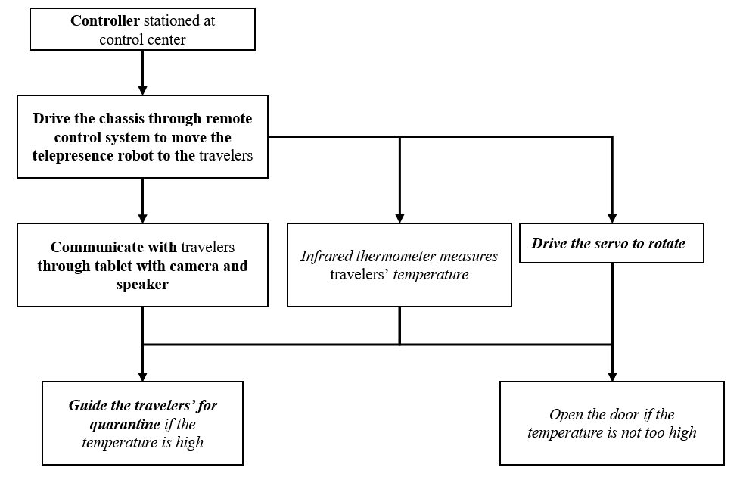

Figure 11: Flow chart for remote temperature measuring scenario

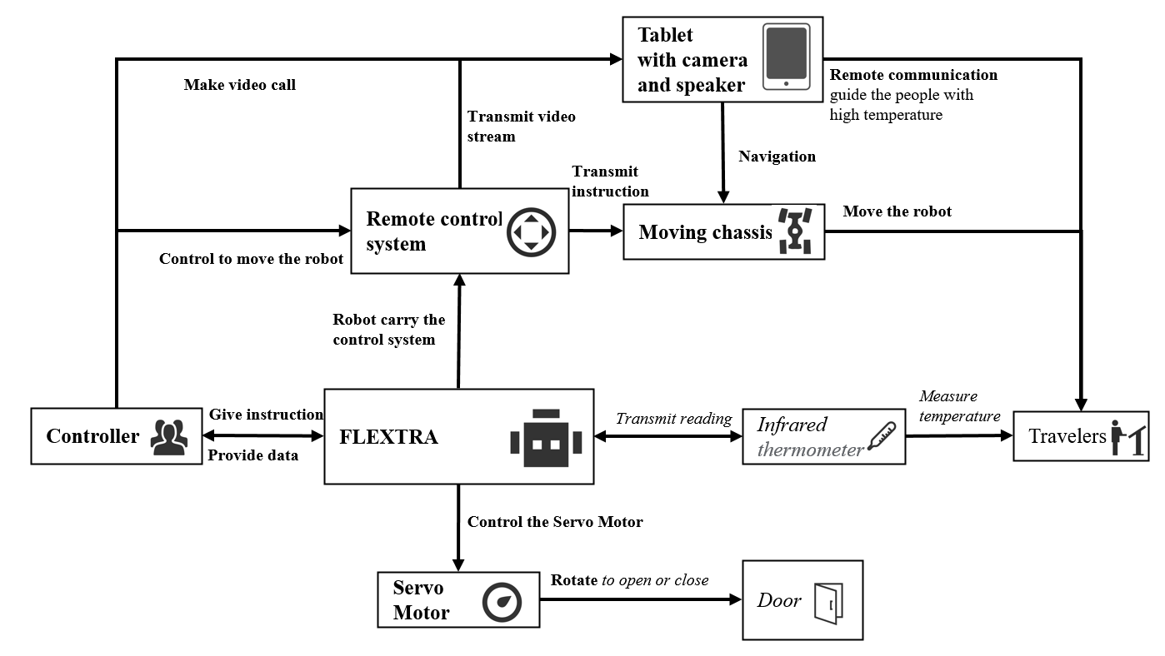

Figure 12: Architecture diagram for remote temperature measuring scenario

### 7.2.2 Remote consultation and reception for medical service

The remote consultation robot can effectively manage pandemic by reducing contact between doctors and people who come to the hospital, since they are potential virus carriers. Usually, doctors will update their schedule on the robot, so that patients can make reservation easily. The FLEXTRA can also give basic treatments after making simple tests for patients, like measuring the temperature. If the doctor is available, he or she can communicate with patients through video call and make remote diagnosis.

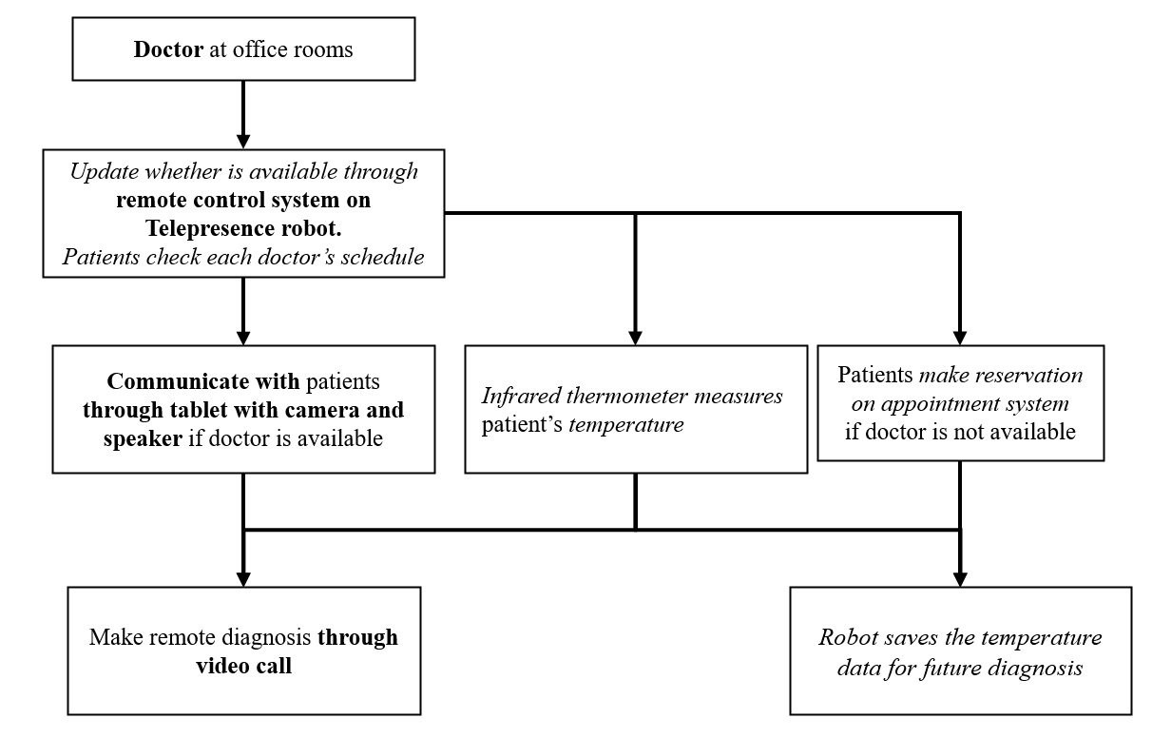

Figure 13: Flow chart for remote consultation and reception scenario

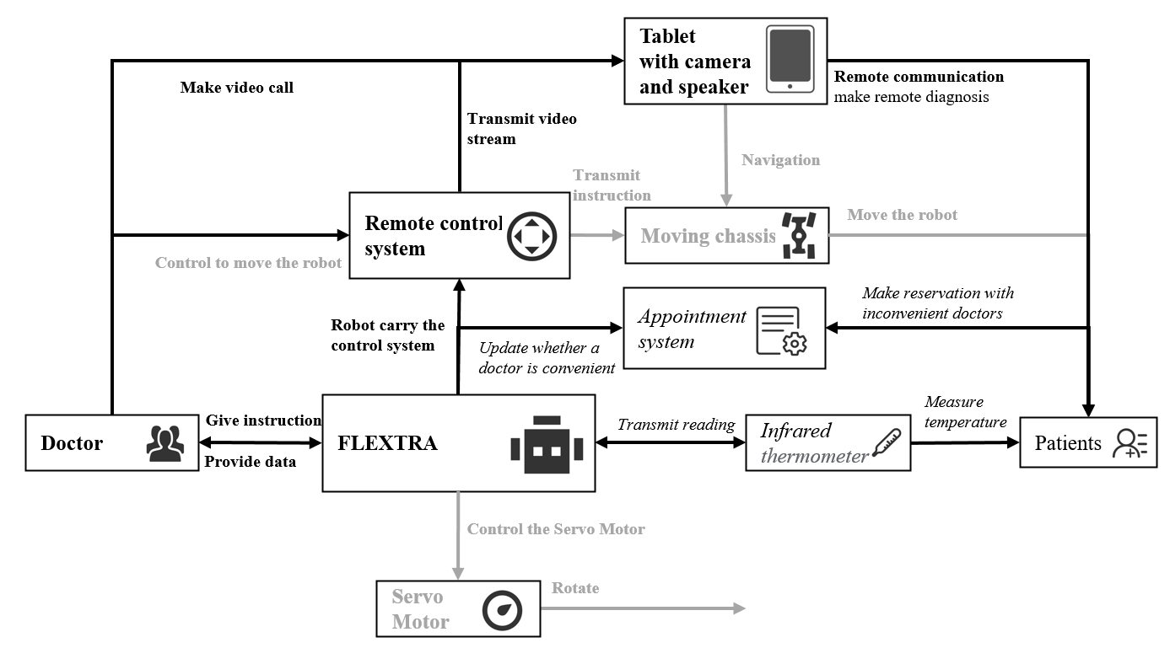

Figure 14: Architecture diagram for remote consultation and reception scenario

### 7.2.3 Contactless delivery of food and medicines

FLEXTRA can provide contactless delivery of food or medicine in wards, which are full of virus carriers. The robot can save much resources since it doesn’t need protection measures taken by human doctors and nurses. The medicine dispenser can be used to dispense food as well. The video call and remote-control system can provide doctors with guidance and communication with patients. The robot can measure patient’s temperature quickly when delivering food or medicine.

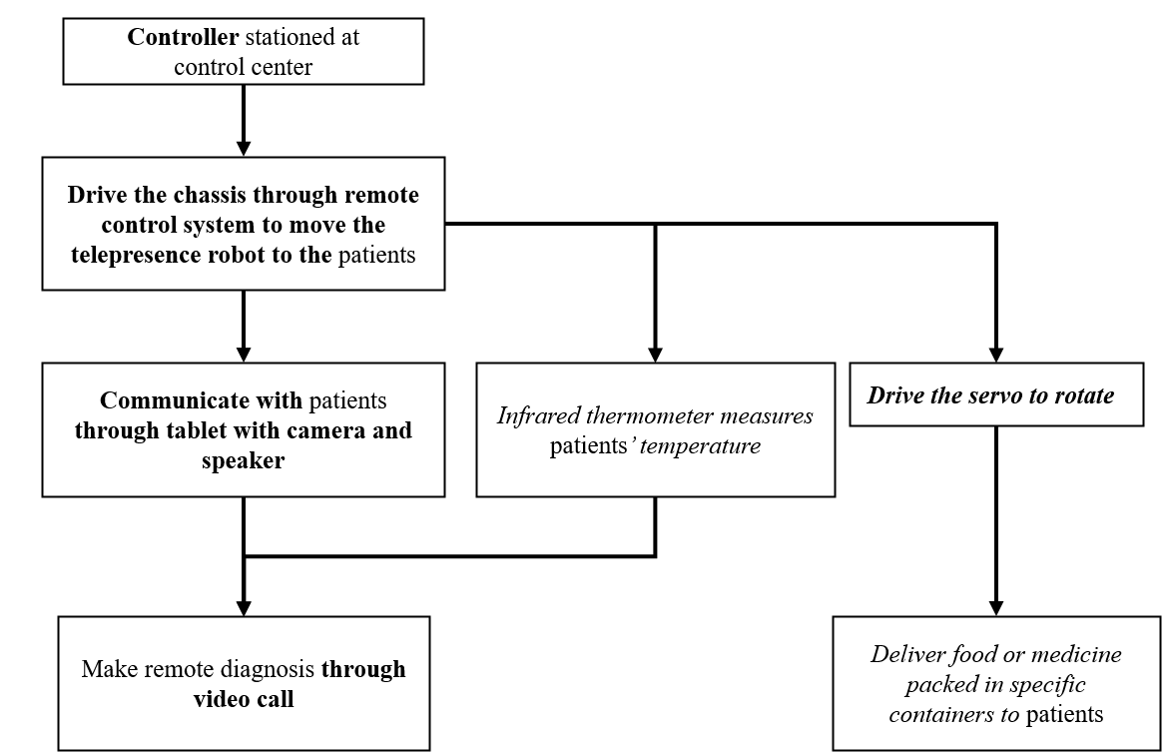

Figure 15: Flow chart for contactless delivery scenario

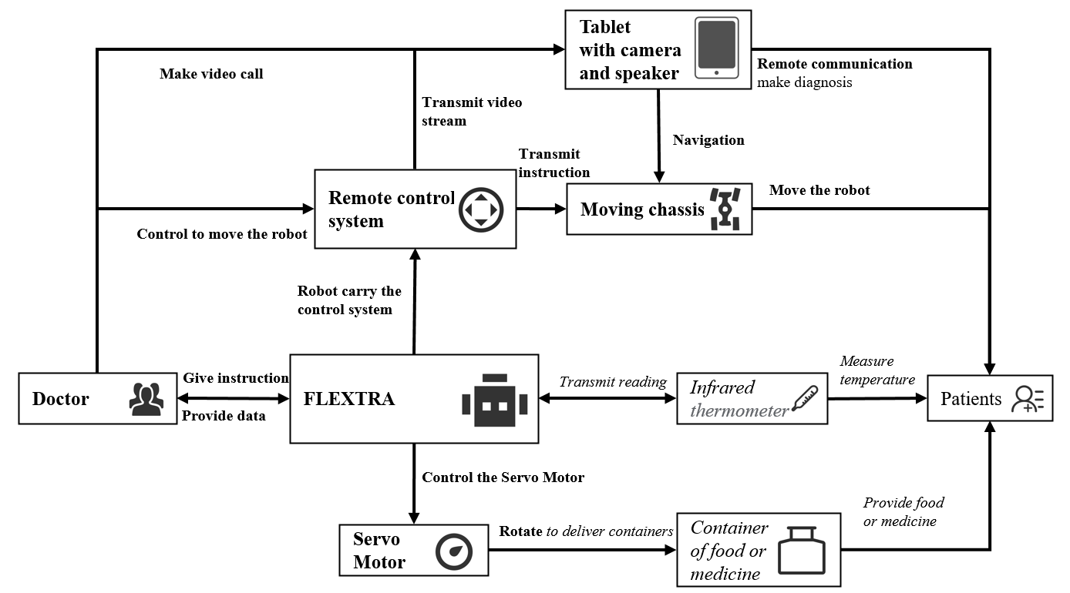

Figure 16: Architecture diagram for contactless delivery scenario

### 7.2.4 Disinfect rooms and remove germs

The robot can disinfect rooms and remove germs through spray and ultraviolet light. Users can stay outside and monitor the progress through remote-control system.

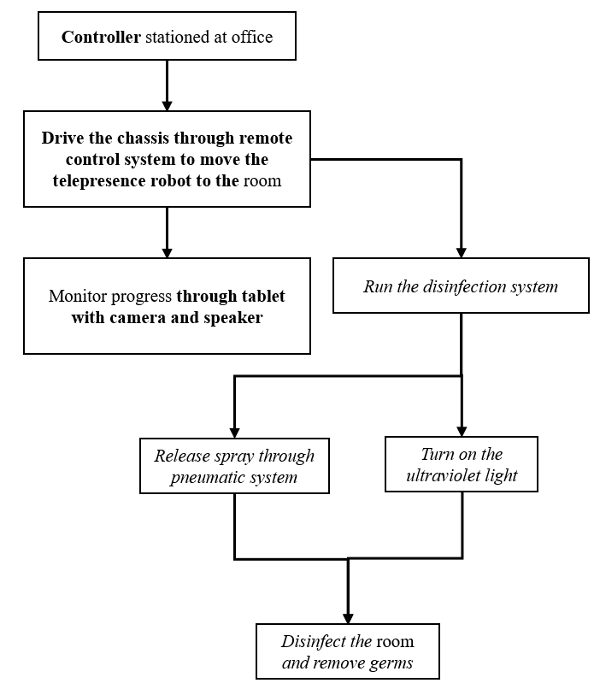

Figure 17: Flow chart for room disinfection scenario

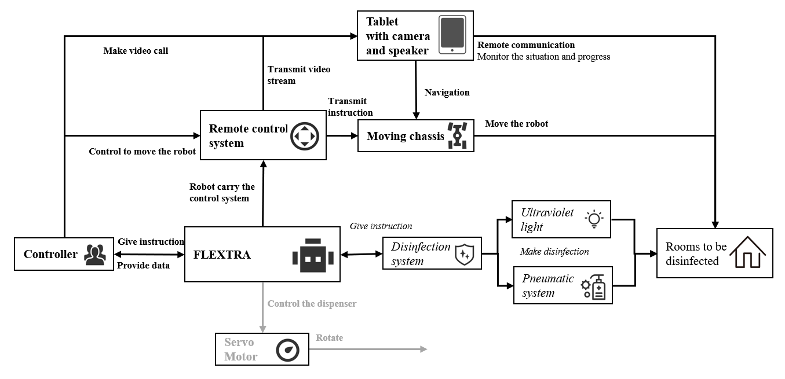

Figure 18: Architecture diagram for room disinfection scenario

## Conclusions

Telepresence robots are still a relatively new technology in which a person can transmit his presence by controlling a robot with his projection on a screen, the idea is that someone can be present in the room even though they are located anywhere in the world. Telepresence robots can be particularly useful for elderly care, where family members can control the robot and give attention to the elderly on a more regular basis, with additional functions such as being able to monitor the medication intake and being alerted when a fall has been detected. However, current telepresence robots for the elderly are expensive according to the users[9], around 5 to 15 thousand dollars for a model, the persistent connectivity issues also make it hard to operate and control, causing a negative feedback from the elderly and caretakers alike[9]. Hence this paper presents a systematic design and implementation of a low-cost (approx. US$500) telemedicine robot.

The infectious nature of pandemics like COVID-19, makes it necessary for telepresence robots to be used (between patient and health professionals) to reduce the chances of infection. We have also discussed how this telepresence robot can be used for five types of COVID-19 application scenarios.

We started with the telepresence robot specification used in EU Victoryahome project for aged care. We carried out a contextual evaluation of this robot for aged care in China through the largest aged care provider company in China. The initial customer feedback is encouraging but more thorough evaluation is needed.

## Acknowledgment

The project was partly supported by the capstone project team of the UM-SJTU Joint Institute in Shanghai, China. This is to acknowledge the support of the Leader of VictoryaHome project Prof Artur Serrano of NTNU, Norway for his support in the Robots for Elderly Project in mHBR. Authors would also like to thank A/Prof Donald Kerr of the University of Sunshine Coast for his leadership role in mHBR Robots for Elderly Project.

## References

1. Pew Research Centre. Attitudes about aging: a global perspective. 2014.
2. National Seniors Australia. The future of aged care in Australia. 2010.
3. Miskelly FG. Assistive technology in elderly care. Age and Ageing. 2001;30(6):455-8.
4. Steele R, Lo A, Secombe C, and Wong YK. Elderly persons’ perception and acceptance of using wireless sensor networks to assist healthcare. International Journal of Medical Informatics. 2009;78(12):788-801.
5. Demiris G, Charness N, Krupinski E, Ben-Arieh D, Washington K, Wu J, and Farberow B. The role of human factors in telehealth. Telemedicine and e-Health. 2010;16(4):446-53.
6. Wu YH, Fassert C, and Rigaud AS. Designing robots for the elderly: appearance issue and beyond. Archives of Gerontology and Geriatrics. 2012;54(1):121-6.
7. Moyle, W., Jones, C., Cooke, M., O’Dwyer, S., Sung, B., and Drummond, S. 2014. "Connecting the person with dementia and family: a feasibility study of a telepresence robot," BMC Geriatrics (14:7).
8. Robots vs. coronavirus: Automated delivery, cleaning and imaging against a pandemic (2020, March 12) retrieved 12 March 2020 from https://medicalxpress.com/news/2020-03-robotscoronavirus-automated-delivery-imaging.html
9. Donald Kerr, J Artur Serrano, Pradeep Ray, ”The role of a disruptive digital technology for homebased healthcare of the elderly: Telepresence robot,” Digital Medicine, Year 2018
10. <https://www.doublerobotics.com/>, April 8, 2020
11. <https://ohmnilabs.com/content/custom-robotics-development-ana/>, April 8, 2020
12. [Fighting coronavirus with data, analytics, AI... and robots](https://istart.com.au/news-items/fighting-coronavirus-with-data-analytics-ai-and-robots/), <https://istart.com.au/news-items/fighting-coronavirus-with-data-analytics-ai-and-robots>, accessed April 11, 2020
13. [China unleashes robots in its battle to control coronavirus](https://www.telegraph.co.uk/technology/2020/02/10/robots-battling-coronavirus-outbreak/), <https://www.telegraph.co.uk/technology/2020/02/10/robots-battling-coronavirus-outbreak>, accessed April 11, 2020
14. [Robots take on coronavirus - The Jerusalem Post](https://www.jpost.com/HEALTH-SCIENCE/Robots-take-on-coronavirus-618551), <https://www.jpost.com/HEALTH-SCIENCE/Robots-take-on-coronavirus-618551>, accessed April 11, 2020
15. [Coronavirus response growing from robotics companies](https://www.therobotreport.com/coronavirus-response-growing-robotics-companies/), <https://www.therobotreport.com/coronavirus-response-growing-robotics-companies>, accessed April 11, 2020
16. [Germ-zapping robots at Scottsdale hospital kills ...](https://www.azfamily.com/news/germ-zapping-robots-at-scottsdale-hospital-kills-coronavirus-nearly-of/article_6c51bd7a-4a29-11ea-a561-97d8243c6f02.html), <https://www.azfamily.com/news/germ-zapping-robots-at-scottsdale-hospital-kills-corona>, accessed April 11, 2020
17. https://gss1.bdstatic.com/9vo3dSag xI4khGkpoWK1HF6hhy/baike/crop%3D56 %2C0%2C520%2C343%3Bc0%3Dbaike80%2C5%2C5%2C80%2C26/sign=f63045 cb3ffae6cd18fbf12132863908/78310a55b319ebc4d65ed2658826cffc1e171623.jpg
18. Yap, A.F.; Thirumoorthy, T.; Kwan, Y.H. Systematic review of the barriers affecting medication adherence in older adults. Geriatr. Gerontol. Int. 2016, 16, 6993a7001
19. Reeder, Blaine, et al. aOlder Adults Satisfaction with a Medication Dispensing Device in Home Care.a Informatics for Health Social Care, U.S. National Library of Medicine, Sept. 2013, www.ncbi.nlm.nih.gov/pmc/articles/PMC4122419/
20. Sumo Guide. aBest Automatic Pill Dispenser - Top 10 Reviews 2019.a Sumo Guide — The Ultimate Shopping Guide Product Reviews, Sumo Guide Team Https://Sumoguide.com/Wp-Content/Uploads/2016/09/SumoGuide-Logo300x100.Png, 31 July 2019, sumoguide.com/best-automatic-pilldispenserreviews/.
21. American Society of Health-System Pharmacists. ASHP guidelines on the safe use of automated dispensing devices. Am J Health-Syst Pharm. 2010; 67:483a90.
22. Reeder, Blaine, et al. aOlder Adults Satisfaction with a Medication Dispensing Device in Home Care.a Informatics for Health Social Care, U.S. National Library of Medicine, Sept. 2013,[www.ncbi.nlm.nih.gov/pmc/articles/PMC4122419/](http://www.ncbi.nlm.nih.gov/pmc/articles/PMC4122419/)

## APPENDIX A

**JI Group:** Can you please introduce your daily work?

**Haiyang Group:** I’m the dean of the nursing home, and I manage the whole nursing home including annual plan, staff responsibilities, coordination with people from inside or outside, connection with the government and cooperation with other charities.

**JI Group:** Who does your nursing home mainly serve.

**Haiyang Group:** The elderly and disabled. We don’t take psychopaths or patients with infectious disease.

**JI Group:** What kind of service do you usually provide for these people?

**Haiyang Group:** We take care of them, provide them with food, help them take a shower, and help them see a doctor. We also hold different kinds of events to make them happy and provide mental care and support.

**JI Group:** You will only invite people from the community to these events or people outside?

**Haiyang Group:** Both. Some volunteers from the university for the elderly will join our events. They will also make some performance for the elderly here. Elderly nearby will also join these events.

**JI Group:** From the pictures posted by you on WeChat, these old people looks very happy.

**Haiyang Group:** Yes, you can come to our nursing home and see it by yourself. So that you can understand their needs and life.

**JI Group:** We really want to go to your nursing home and see it, but we are too busy this semester. We know there are two kinds of service for the elderly, including community support for the elderly and service support. What’s the difference?

**Haiyang Group:** I can’t give you the exact answer, I only run an institution for the elderly. I think community support for the elderly is like daycare.

**JI Group:** What difficulties do you think exists in the service for the elderly.

**Haiyang Group:** From my point of view, many old people and relatives don’t want to go to nursing home because of their old concept. We also lack professional staff to provide service.

We don’t have much income and revenue so we can’t attract the young people by providing them with high salary.

**JI Group:** Can you talk about more details about the shortage of professional staff?

**Haiyang Group:** We lack nurses, doctors and nursing assistant. Actually, we have enough people, but we lack people who meet our requirements. This problem can’t be solved by remote healthcare, we need these people on the scene to serve the elderly. The government also have such requirements for the number of people on the scene.

**JI Group:**Let’s see a video of a healthcare telepresence robot. This is a prototype that we’re working on.

**Haiyang Group:** The elderly will use these robots at home?

**JI Group:** Either at home or in the nursing home. We plan to use this robot to provide medicine, diagnosis, and remote video communication.

**Haiyang Group:** Based on Chinese law, only nurses with certificate can give medicine to the elderly. It doesn’t matter if you only use the robots at home, but we’re supervised by the government in nursing home and they have specific requirements.

**JI Group:** From nursing home’s view, what kinds of role can robot play to serve the elderly?

**Haiyang Group:** The robot that can play with the elderly, or design a game for them, or provide 24-7 care for the elderly. These old people usually feel bored since they can only lie in bed and can’t move. They’ll also feel lonely since nursing assistant can’t always stay with them. Robots can tell stories for them, but there may exists a language barrier since China have many kinds of localism. Some of our elderly people want to speak and practice localism but the robot can only speak mandarin. This video shows the old people are doing physical exercise. Robots can teach them how to do some exercise. Robots can also help take videos or photos, since our monitoring system has blind spots.

**JI Group:**We’re thinking whether robots can provide some physical interaction with the elderly, like playing games.

**Haiyang Group:** My husband’s company make rehabilitation robot. The elderly tends to be paralytic after getting sick. Robot can help them exercise limbs. Robot can also record the elderly’s songs and play the recording. But some old people may not have a clear mind, so they may destroy the robots.

**JI Group:**So we must make these robots very strong. What else can you think of except for these functions?

**Haiyang Group:** Many old people can’t read, so it’s better if the robot can be controlled by voice. Nurses are not quite familiar with how to operate a computer, so the robots’user interface should be very simple. In addition, robots here also require WIFI or Internet, so they are unstable. You can set some sensors on the robot, so when the elderly fall or yell “Help me”, it can notify the nursing station.

Patrol robot may also be quite useful, like they will check every room and take a picture in the evening. Nowadays, we go on patrol everyday by ourselves.

**JI Group:** Do the elderly accept robots. Will they be afraid?

**Haiyang Group:** Those with a clear mind won’t be afraid.

**JI Group:** Can we use robots to hold volunteer service. Volunteers can chat with the elderly through screen, camera and speaker on robots.

**Haiyang Group:** Yes.

**JI Group:** From the video of robots, can you mention some defects or defaults?

**Haiyang Group:** Whether can use a robot to deliver a medicine depends on the law.

**JI Group:** From our design, we want to let nurses control the robot to deliver the medicine. So it’s not fully automatic.

**Haiyang Group:** There is a risk since the robot may give the wrong medicine.

**JI Group:** What if there is someone supervising the robot?

**Haiyang Group:** It depends on the law. There will be serious consequence if the elderly eats wrong medicine.

**JI Group:** It seems more practical if the robots are used to play with the elderly.

**Haiyang Group:** Yes, they also need a stable chassis.

**JI Group:** If we modify the robot prototype so that it can interact with the elderly, how much would you like to pay for it. A price for reference is 7000 RMB.

**Haiyang Group:** It’s too expensive. The price we accept is a litter higher than a tablet, like 3000 RMB. But it also depends on the robots’functions.

**JI Group:** What function will satisfy you most?

**Haiyang Group:** Accompanying old people, monitoring their status or social interacting with them. But the robot must be suitable for them. I heard Japan have some tablets especially for the elderly. All apps on the tablet are specially designed for the elderly.

**JI Group:**We’ve found some robots mimicking animals.

1. <https://www.scmp.com/tech/policy/article/3049215/ai-firms-deploy-fever-detection-systems-beijing-help-fight-coronavirus> [↑](#footnote-ref-1)
2. <https://www.youtube.com/watch?v=2YI1_guPMCc> [↑](#footnote-ref-2)
3. <https://www.youtube.com/watch?v=o2VhThCzFwg> [↑](#footnote-ref-3)